Article 1 - Text to Voice on Your Android Phone (pretty good actually)

First select Setup

Select “Accessability”

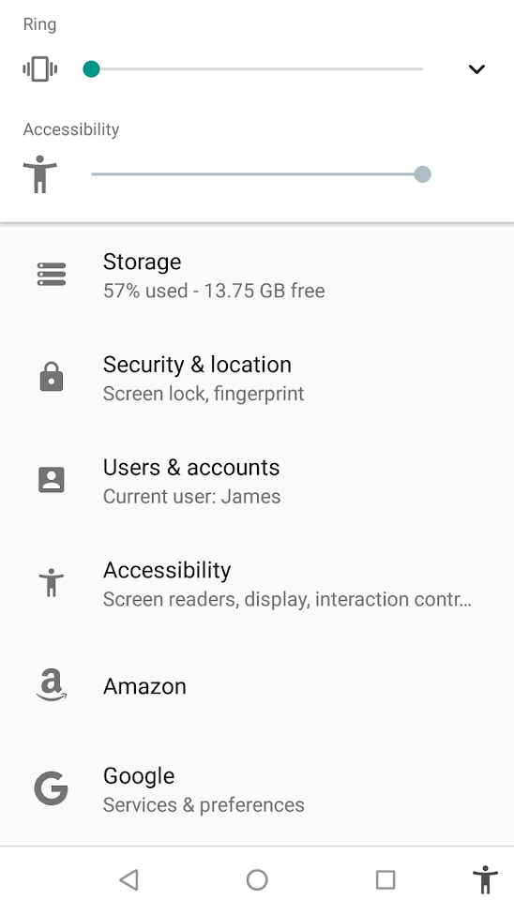

Select “Select to Speak” (ON / Hear Selected Text)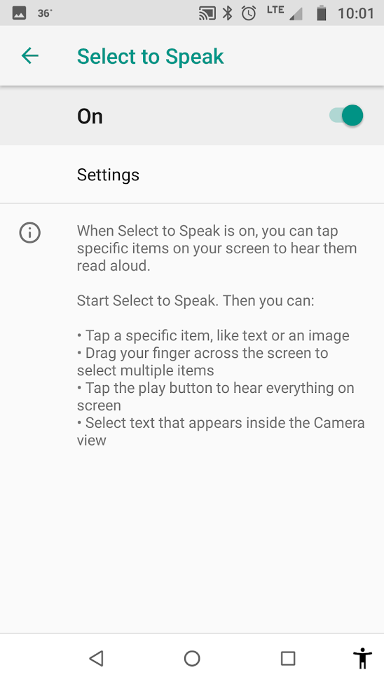

With this selected your phone will read the page your are currently viewing in the Google browser.

You scroll to the page you want to listen to and click the little person in the bottom right corner of the screen. (see below).

Click the Play button and away you go.

The left arrow button will expand the playing options for additional options.

P.S. If you are scrolling within a window with a “fixed” header the information in the header will also play. Sometimes it will play the entire html text prefix so you will learn to avoid the preamble.

